**An Evolution in Intercultural Studies: Introducing Intercultural Communication Needs Model and Triple Needs Theory in English Language Teaching**

**Abstract**

Developing a new model and theory along with key macro-elements in intercultural studies was a big gap and problem for more than a decade. The current study filled this gap by introducing the intercultural communication needs model (ICN) and Triple Needs Theory (TNT). Thus, the researchers selected 100 participants to partake in this study to collect the required data. 20 participants out of 100 willingly took part in interview sessions, too. The researchers used a mixed methods design and complex quantitative and qualitative methods such as exploratory and confirmatory factor analysis along with inductive content analysis to collect and analyze the data to develop the model and theory. The results showed that The ICN model and triple needs theory (TNT) introduce language, emotion, and culture as the newest macro-elements of intercultural interactions. Also, the results revealed that contextual and individual factors influence the priority and selection of these three needs: language, emotion, and culture. This study is of high significance for language instructors, intercultural and cultural psychologists, and politicians in that it helps them to ameliorate the quality and effectiveness of their instruction, therapy, and political meetings respectively.

**Keywords:** intercultural communication needs model, triple needs theory, linguistic needs, affective needs, cultural needs

**Introduction**

Intercultural communicative competence alludes to one's capacity to interact successfully with individuals from diverse social foundations. Subsequently, it went from a monocultural position to an intercultural position (Deardorff, 2006, Jackson,2014). Lloyd and Härtel (2010) identified three subsets of intercultural communication, that is, cognition-based, emotional, and behaviour-centred facets. Other scholars such as Byram (1997) declared that intercultural communicative competence included attitude, knowledge, skills of interpreting and relating, skills of discovery and interaction, and critical cultural awareness.

The link between language, culture, and intercultural communication was the center of numerous researchers including Samovar et al. (2007), Malakloluntu and Selan (2011), Kramsh (2013), etc. These researchers focused that it is not possible to demarcate language and culture or disregard their significance in intercultural encounters. Few inquiries emphasized the part of emotions in intercultural investigations, for example, Matsumoto et al. (2009) were among other scientists who did some inquiry on the impact of emotions in intercultural communications. Tenzer and Pudelko (2015) asserted that the link between language, emotion, and culture was the missing link in intercultural studies. Few studies investigated the connection between emotion, language, and intercultural communications, and the findings revealed that language obstacles could bring about non-positive emotions such as anger, sadness, and so on (Tenzer and Pudelko,2015, Matsumoto, 2007).

During the history of intercultural communications, many gaps and problems remained unsolved and this paper is going to solve some of these problems and fill some gaps. One of the main gaps and problems is the over-repetition of ICC parts such as knowledge, skills, attitude, and awareness. So to solve this problem, we need some new macro-elements to act as umbrella terms. The second problem is that the role and importance of language have been ignored in intercultural studies history. Finally, the most significant gap in the history of intercultural studies is the lack of a solid theory and model of intercultural communication (Suanet &Vijver,2009). Thus, this paper is of high significance since it is going to obviate these gaps and problems by introducing a new theory and model of intercultural communication which focuses on language, emotion, and culture as its main macro-elements. It should be stated that no new and leading model or theory has been developed in the field of intercultural communication for about two decades. The Intercultural Communication Needs model (ICN) and Triple Needs Theory (TNT), which is a need-based model and theory, is the output of a five-year research study that is going to explain the importance of language and introduce new umbrella terms as parts of ICC. The Intercultural Communication Needs (ICN) model and Triple Needs Theory (TNT) can be the most comprehensive model and theory in the field of intercultural communication since Deardorrf’s models in 2004 and 2006. This model and theory assist language teachers, instructional institutes, intercultural and cultural psychologists, and politicians to ameliorate the quality of their intercultural instruction, cultural therapy, and intercultural and political interactions respectively. In a nutshell, this paper tries to shed more light on the ICN model and Triple Needs Theory (TNT) as the newest model and theory in intercultural studies and also explain their differences from previous theories and models. Therefore, the present paper is going to provide an answer for the following research questions:

1. What are the main ingredients of the Intercultural Communication Needs (ICN) model and the Triple Needs Theory (TNT)?
2. What is the difference between the ICN model and the Triple Needs Theory with previous models and theories of intercultural communications?

**Review Literature**

**Language, Culture, and Emotion in Intercultural Communication**

Samovar et al. (2007) expressed that culture could be a complex and theoretical concept that applies an inescapable impact on each angle of your life. Malakloluntu and Selan (2011) touched upon that language is the greatest problem for international students. Lots of pupils encounter expression and comprehension troubles since English is not their first language though they can converse in English. In other words, language works as a tool of cultural growth. Language is the main device of keeping the culture and is the tool of transferring culture to new descendants” (Samovar et al., 2007, p.166).

The improvement of intercultural competence with language makes a difference in taking off biases and stereotypes. It comes about bilingualism and biculturalism (Fantini, 2006). The matter of teaching culture in the scope of FL classes has long been a matter of contention by scientists and teachers. Most of them keep up the conclusion that a second language can seldom be taught without instructing the culture of the society in which the language is obtained (Kramsh, 2013).

Separated from language, intercultural encounters focus on social calibers, designs of thought, and distinctive people's cultures. It also incorporates comprehending the multifarious cultures, languages, and traditions of people from other nations (Lauring, 2011). English language teaching could be portrayed as a way of intercultural communication between students’ first language or culture and their second language or culture. English language teaching suggests specific outlets for students to encounter intercultural communication and brings about their individual development to become intercultural speakers (Zhang, 2015).

The knowledge of second language culture is a crucial agent as the essentials of the language such as syntax or vocabulary. What is more relevant is that the need for intercultural awareness could work as an incredible obstruct to the understanding of a meaning that is right and comprehensible from a linguistic perspective. People are much less tolerant of cultural bumps and cultural shocks compared to grammatical or word botches (Jie, 2010). In another study, Ghorbani and Dowlatabadi (2023) examined the role of culturally laden text on the intercultural level of language teachers and found that teachers’ ICC levels improved. In the same vein, in a quantitative study, Ghorbani and Dowlatabadi (2023) found that culture, emotion, and language could be the main parts of intercultural communication.

Emotion could be elaborated as “a mental state of action readiness that originated from the cognitive appraisal of events or thoughts; had a phenomenological tone; was accompanied by physiological processes; and was often expressed physically” (Bagozzi et al., 1999, p. 184). Tenzer and Pudelko (2015) found that language hampers could cause non-positive emotions among people in multinational groups. Both the link between cultural records and language alteration and that between language alteration and affective response are disregarded ingredients in the process of intercultural interactions. Also, in a mixed-design study, Ghorbani and Dowlatabadi (2024) discovered that any intercultural communication consists of affective, linguistic, and cultural needs.

Transcultural interactions may bring about miscellaneous non-positive feelings. For example, fresh traditions may create anxiety; communication troubles may lead to disappointment; and misconceptions or biases may lead to fear, anger, or contempt. Therefore, the capability to control such negative affective facets should be important in the growth of cross-cultural competence (Matsumoto, 2009; Reid, 2010).

Fruitful intercultural communication can restrict the non-positive feelings of people and this can occur via utilizing a shared language of communication because this shared language transfers a positive affective reaction to fill the communication vacuum (Vaara et al., 2005). Tenzer et al. (2014) explicated that while emotions were enhancing, people often spontaneously altered to their native language in intercultural encounters but excited emotions of “irritation” “discomfort” and “suspicion” in their foreign coworkers. Also, Ghorbani and Dowlatabadi (2023) found that intercultural communication could have miscellaneous sources of failure, that is, linguistic, cultural, and affective failure.

**Models of Intercultural Communication**

**Byram’s (1997) Multidimensional Model of Intercultural Competence Model**

Byram’s model (1997) focused on five Savoirs or areas of knowledge in intercultural communication. The model consists of knowledge of social and cultural rules, interpretation of texts, suspending between cultures, ability to put new things into practice, and ability to evaluate critically. Though Byram’s model was introduced in English language teaching, it didn’t pinpoint the importance and exact position or its effect on intercultural communication.

**Deardorff's (2004,2006) Pyramid and Process Model of Intercultural Competence**

In 2004 and 2006. Deardorff introduced pyramid and process models of intercultural communication. These models consist of motivational, cognitive, and skill elements along with contextual factors. In sum, these models included attitude, valuing cultures, mindfulness, listening, observing, etc. Also, the models introduced internal and external outcomes. Deardorff’s models were related to the field of education, not English language teaching, therefore, there is no sign of language elements in these two models. She didn’t even allude to the importance or position of language and linguistic elements in her models.

**Theories and Approaches of Intercultural Communication**

Many theories and approaches came into the field of intercultural communication from other fields including psychology, sociology, discourse analysis, and so on (Abba Auwalu, 2015). For example, social sciences approaches had roots in psychology and sociology which explained human behaviour based on external predictable realities. Culture and personality features are the variables that affect human interaction (Judith and Nakayama, 2007). In face negotiation theory, there are three elements such as knowledge, mindfulness, and interaction skills. The knowledge has the lion’s share in the theory. These elements focused on the ways of interactions and assessment in different situations (Ting-Toomey and Kurogi, 1998: 204,cited in Panocova, 2020).

Another theory is accommodation theory which emphasizes concepts such as in-groups and out-groups, convergence and divergence styles, and also linguistic and non-linguistic features of language. Put simply, the theory emphasizes that people adapt their verbal interactions to simplify comprehension (Nakayama and Judith, 2007). The interpretive approach in intercultural communication refers to the emic and etic view of culture study. Interpretivists study culture subjectively from within a given cultural society or context (Abba Auwalu, 2015).

The other important approaches were critical and dialectical in intercultural approaches. The critical approach focused on cultural variations and power tensions in society. Power struggle and emancipation of people are the focus of this critical approach (Sadri & Flammia et al, 2011). The dialectical approach focuses on Cultural-individual, personal-contextual, differences-similarities, static-dynamic, history/ past-present/future, and privilege-disadvantage are the six dialectical features of the dialectical approach. These dialectical features are pertinent to four important parts of ICC: culture, communication, context, and power (Martin, Nakayama, and Flores, 2002).

**Need and Basic Needs Approach**

Maslow (1943) raised a theory of how all aspects of motivation are intermingled, according to the notion that human conduct is specified by a small number of growing basic needs that appear and act in sequential order (Sengupta, 2011). Maslow’s theoretical principles revealed that it is vital for previous needs to be met before the higher-level need appears and the individual becomes concerned by meeting it (Taormina and Gao, 2013).

Gil (2013) accentuated that persons and societies dynamically meet their needs in paths that rely upon their social conditions. Sengupta (2008) confirmed the hierarchy of needs, stating that it is a requisite to see human needs as objective, universal, and transcultural. The basic needs theory introduced the concept of *priority*. Language is an influential tool to transfer the deepest and highest wants, dreams, and opinions of humanity. Diaz-Rico (2009) expressed that language aids us to fulfill our potential, to share our inner selves with others, or to act upon the world strongly (p. 1).

**Methodology**

**Participants and Sampling**

One hundred (100) Iranian language teachers were selected through a convenience sampling procedure as the ultimate participants of the current study. The researchers used a convenience sampling procedure since the participants’ willingness, availability, and accessibility were taken into consideration. The demographic data revealed that the age range of the participants was between 22 and 40 years old and all the participants had a BA and MA degree in English language teaching. It should be noted that the current study included participants from different ethnicities in Iran to serve the intercultural purpose of the study.

**Research Design**

Given the nature and purpose of the study which focused on model and theory making, along with the use of complicated quantitative and qualitative methods, the researchers decided to use mixed-methods design to serve the purpose right. In other words, the researchers used explanatory sequential design which is an important type of mixed-methods design. In explanatory sequential design, first the quantitative data was collected, and then the qualitative data. The qualitative data shed more light and support the quantitative data.

**Instrumentation**

Given the nature of the study which consisted of both quantitative data and qualitative data the following instruments served the purpose right:

**Demographic Form:** Background information of the participants was collected using the Demographic Information form including age, ethnicity, place of residence, level of English language proficiency, etc.

**ICC Questionnaire:** The ICC questionnaire developed by Kazykhankyzy (2019) was used by the researchers to collect the prerequisite data regarding intercultural communication. It should be stated that the reliability coefficient of the questionnaire was .958 which revealed the questionnaire has high reliability (Kazykhankyzy, 2019).

**Interview:** Structured Interview was another important instrument for the current study. The interview questions were formulated based on the purpose of the study by the researchers and the validity of the questions was checked through member checking and peer debriefing.

**Data Collection Procedure**

To collect the required data, the researchers used an ICC questionnaire to gather the data for the quantitative section and an interview for gathering the qualitative section. The participants fill out the questionnaire and the researchers classify the answers under the themes of language, emotion, and culture by using exploratory factor analysis and rotation matrix. After completing the questionnaire by the participants, the participants went through the interview section. Twenty (20) participants took part in structured interview sessions willingly and answered the questions. The researchers assured the participants to remain anonymous. Because of the concurrency of the study with the COVID-19 pandemic period, it should be mentioned that the interview questions were sent through Skype and WhatsApp soft wares to participants. Then they answered the questions orally and sent them to the researchers.

**Data Analysis procedure**

To analyze the data, the researchers analyzed the questionnaire first and then the interview data. In quantitative analysis, the researchers applied exploratory factor analysis along with a component rotation matrix to classify and group the answers under language, emotion, and culture themes. It should be mentioned that researchers corresponded with the designer of the questionnaire a lot for grouping and classifying the questions and answers. Then the researchers used confirmatory factor analysis, standard solution coefficient, and T-value to analyze the data to show the main parts of the model, and also the researchers calculated the validity and reliability of the model. In qualitative analysis, the researchers used inductive content analysis to analyze the data. Using initial and secondary coding analysis, all the interview transcripts were coded, categorized, and analyzed. Also, the researchers used an in vivo and descriptive coding process to code the data (Saldana, 2015). To make sure of the reliability of the data, the researchers used inter-coder reliability in which another person was asked to code the same texts of the transcript whether he/she would find the same results or not. The validity and credibility of the study were checked by member checking and peer debriefing. Some of the participants and researchers were asked to check the answers to the interview questions to confirm the answers as valid and credible.

**Results and Discussion**

**Quantitative Results:**

This section deals with the quantitative analysis of the data. By using exploratory factor analysis and rotation matrix, the questions and answers were grouped and classified under three variables, that is, language, emotion, and culture. Table 1 shows the number of questions for each variable.

**Table 1.**

*EFA and Rotation Matrix Result*

|  |  |
| --- | --- |
| Variables Number |  |
| Language 21 |  |
| Emotion 14 |  |
| Culture 17 |  |

Table 1 revealed that 21 questions and answers were pertinent to the language variable, 17 questions and answers to the culture variable, and 14 questions and answers to the emotion variable. It is worth mentioning that the researchers corresponded a lot with the designer of the questionnaire about the nature and grouping of the questions and answers, that is, Kazykhankyzy (2019). After grouping and classifying the questions and answers under these variables, the researchers calculate the validity and reliability of these variables to make the model. At first, the composite reliability of the model was calculated. The amount of composite reliability should be more than the 0/7 threshold value and it should have at least a significance value of 0/05. Table 2 shows the composite reliability of the variables. The composite reliability of the variables has been confirmed, that is, the composite reliability for culture was 0.991, emotion 0.993, and language 0.980 respectively.

**Table 2.**

*Composite Reliability Measurement of Variables*

|  |  |  |  |
| --- | --- | --- | --- |
| Variable | CR | T Statistics | P Value |
| Culture | 0.991 | 347.259 | 0.000 |
| Emotion | 0.993 | 445.655 | 0.000 |
| Language | 0.980 | 204.815 | 0.000 |

To investigate the convergent validity of the measurement model, average variance extracted (AVE) was utilized. Convergent validity was fit when the average variance extracted equaled 0/5 or more. The results (Table 3) revealed that all the constructs, that is, language, emotion, and culture showed an average variance extracted more than 0/5. Thus, it was concluded that the measurement model enjoyed sufficient convergent validity.

**Table 3.**

*Convergent Validity Measurement*

|  |  |
| --- | --- |
| Variable | AVE |
| Culture | 0.884 |
| Emotion | 0.899 |
| Language | 0.703 |

The Fornell-Larcker criterion was used to investigate the divergent validity of constructs. The square of average variance extracted should be more than the correlation of that construct about other constructs which meant that the correlation of a construct with its indicators was more than its correlation with other constructs. Table 4 shows the results of the divergent validity of the three constructs. The divergent validity of each construct has been confirmed.

**Table 4.**

*Divergent Validity Measurement*

|  |  |  |  |
| --- | --- | --- | --- |
| Variable | Culture | Emotion | Language |
| Culture | 0.940 |  |  |
| Emotion | 0.639 | 0.948 |  |
| Language | 0.717 | 0.666 | 0.838 |

When the validity and reliability of the variables were calculated, the researchers used structural equation modeling along with the standard solution coefficient and T-value to substantiate that language, emotion, and culture are the main parts of the intercultural communication needs model or ICN model. The following figures (FIG.1&2) showed the standard solution coefficient and T-value respectively. Based on the analyzed data so far, the researchers answered the first research question.

**Fig 1.**

*Standard Solution Coefficient in Structural Equation Modeling*

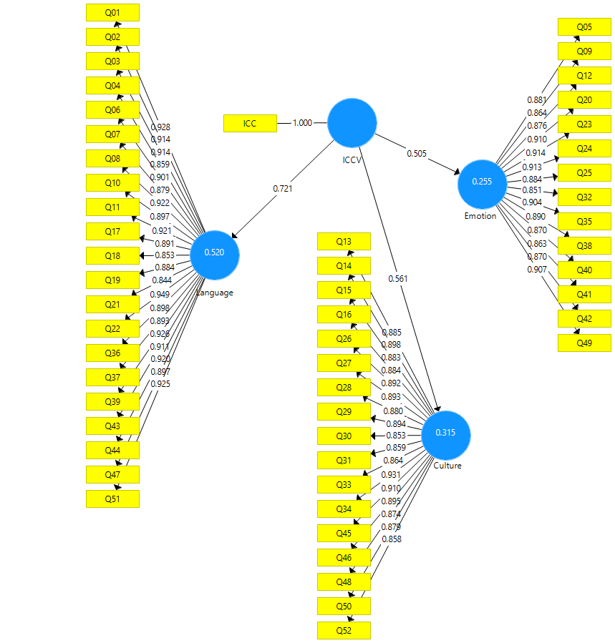

Scientifically speaking, when there exists a relationship or correlation between observable variables with the latent variables, the scientists utilize Factor loadings in the standard solution. The logical value for factor loading is between zero and one (0-1). If the value of factor loading falls below 0/3, the correlation is deemed weak and it is ignored. If the factor loading value falls between 0/3 and 0/6, it is acceptable and if the factor loading value falls higher than 0/6, it is optimal. This figure (Fig 1.) evinced that the connection between language (0.520) and ICC is much higher than culture (0.315) and emotion (0.255), yet culture and emotion also evinced a relationship with ICC. What can be construed from FIG.1 is that language, emotion, and culture form the main parts of the intercultural communication needs model or ICN model. Language is the most important part of culture and emotion.

**Fig 2.**

*T Value in Structural Equation Modeling*

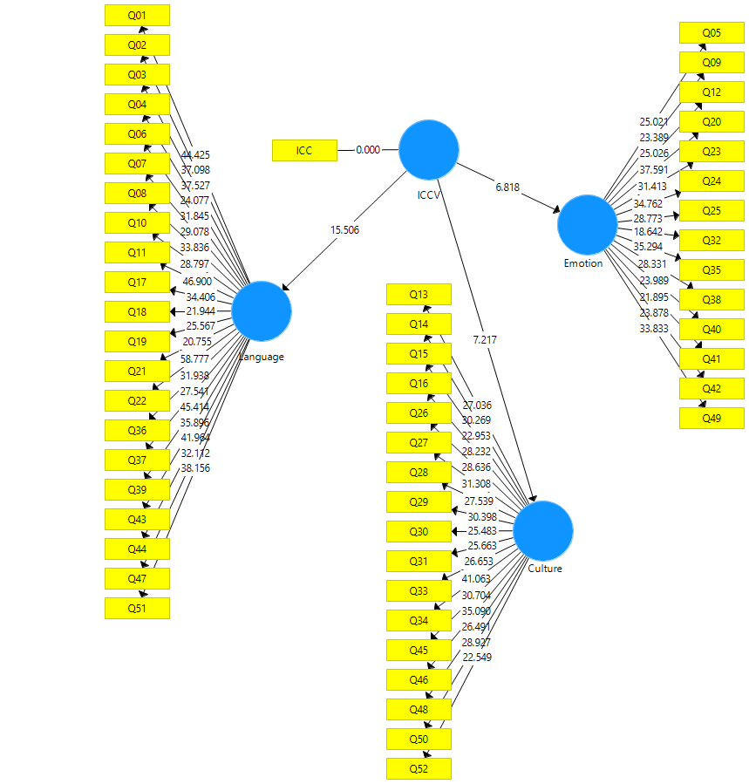

Figure 2 revealed that language, emotion, and culture enjoy a big T value, noting that the T value should be bigger than 1/96, which means that these variables are forming the main macro-needs or macro-elements of ICC. According to this figure (Fig 2.), language (15.506) is deemed as the most vital macro-element of ICC and culture (7.217), and emotion (6.818) are put in second and third place respectively. Therefore, according to Fig 1&2, it is concluded that language, emotion, and culture form the most significant ingredients of ICC. In the same way, Figure 2 evinced that a strong relationship can exist among language, emotion, and culture because T values are applied to disclose the significance level of the relations among constructs. Among these macro-elements, one of the elements acts as a mediator variable. To find the mediator variable, the researchers used Sobel statistics and the following table (**Table 5**) shows the result.

**Table 5.**

*Emotion as a Mediator Variable*

|  |  |  |  |  |
| --- | --- | --- | --- | --- |
| Independent Variable | Mediator Variable | Dependent Variable | Path Coefficient | Sobel Statistics |
| Language | Emotion | Culture | 0.238 | 2.237 |

Table 5 revealed that emotion with %95 certainty acts as a mediating variable between culture and language since the Sobel Value is (2.237) and it is bigger than 1.96. Therefore, the findings proved that emotion is the mediator variable, language is the independent variable, and culture is the dependent variable. Thus, the emotion variable assists the language component in influencing the cultural component.

**Qualitative Results:**

This section deals with qualitative analysis. In this way, the researchers used inductive content analysis along with in vivo and descriptive coding cycles to analyze the interview transcripts. The following showed the results of the qualitative analysis. First, pay attention to the interview questions and then the analysis:

1. As a non-native speaker, do you think what the **needs** for good intercultural communication are, that is, when you interact with people from other cultures?
2. Do you think **language, emotion,** and **culture** can be the main parts of intercultural communication? What is their role and position in an intercultural interaction? Order them based on your viewpoint.

**Table 6.**

*Codes and Themes for Interview Question 1(the first interview question)*

|  |  |  |
| --- | --- | --- |
| Codes | Frequency | Themes |
| Body Language  Understandable Conversation  Cultural Knowledge  Positive Attitude  Motivation  Respecting others  Trusting others  Being non-judgmental | 18  20  17  12  12  12  10  10 | Language      Culture  Emotion |

Table 6 revealed that good intercultural communication could have a myriad of elements. The data and codes disclosed that 18 and 20 participants believed that body language and understandable conversation are the main elements of good intercultural communication respectively. In other words, the participants maintained that a lack of suitable use of these two elements could cause cultural and affective misunderstandings in any intercultural communication. These two elements, that is, body language and understandable conversation are pertinent to the language theme and the quantitative analysis revealed that language is the most important part of the intercultural communication needs model. 17 participants believed that cultural knowledge, which is related to cultural theme, is the most important part of good intercultural communication since it helps people to avoid intercultural and cultural conflicts and misunderstandings. In other words, they asserted that having cultural knowledge helps them to know the cultural and social customs and adapt more easily to others and situations. The quantitative analysis proved that cultural theme is the second important part of the intercultural communication needs model. 12 participants chose Positive attitude, motivation, and respecting others as the most important part of intercultural communication. 10 participants selected trusting others and being non-judgmental as the most important elements of intercultural communication. These elements are related to the emotion theme which is the third important part of the intercultural communication needs model.

**Table7.**

*Themes and Codes for Interview Question 2 (the second interview question)*

|  |  |  |
| --- | --- | --- |
| Codes | Frequency | Themes |
| Language  Culture  Emotion | 12  5  3 | Language  Culture  Emotion |

Table 7 revealed that language, emotion, and culture are the main macro-elements of intercultural communication needs model qualitatively. Participants asserted various orders for these microelements but Table 7 disclosed that language is the most important part of the intercultural communication needs model and the second and third place go to culture and emotion respectively. In other words, 12 participants chose “language” as the most important part of the ICN model, 5 participants chose “culture” and 3 participants chose “emotion”. The participants asserted that the first order of importance could be the **“language, culture, emotion”** order which means that linguistic need is the most important need in this order. The second proposed order is the **“culture, language, emotion”** order which means that cultural need is the most important need in this order. The third order is the **“emotion, language, culture”** order which means that affective need is the most important need in this order.

To answer the second research question, the researchers explain the ICN model and Triple Needs Theory (TNT) first and then elaborate on the main parts of the model and theory. The following shows the intercultural communication need model or ICN model. The intercultural communication needs model or ICN model (Ghorbani & Dowlatabadi, 2023) is a need-based model in the field of intercultural communication whose focus is on the needs of intercultural communications in non-native versus non-native situations but it could be helpful in native-speaking countries, too. This model consists of three macro-needs or macro-elements, that is, linguistic/language needs, emotional/affective needs, and cultural needs. These needs all start simultaneously in any intercultural conversation and they are interrelated. It should be mentioned that these three macro-needs were under the effect of two other factors, that is, context (situation) and individual (interlocutor).

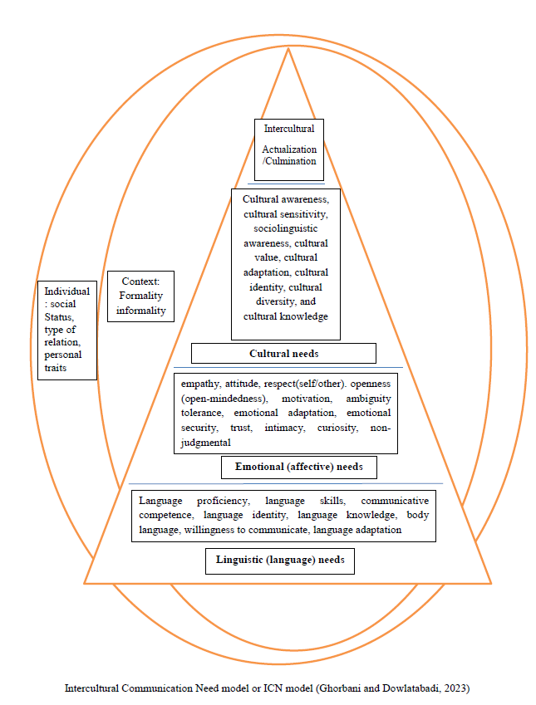

Context and individual determine which needs have to be used first. In other words, context and individual influence the selection and priority of each need. The other feature of the model was that each of these three needs as macro-elements have their sub-components. The ICN model reveals that intercultural communication is not only a competence but also a need. According to the findings of the qualitative analysis, there were three macro-needs and each of these needs was under the effect of context and individual. The researchers concluded that the satisfaction of these needs was reliant on three things: when (time), where (situation/context), and with whom (individual). That is, these needs took different priorities to be satisfied in different temporal, spatial, and personal contexts. Based on the findings of the qualitative and quantitative analyses that there exist three macro-needs in any intercultural communication such as linguistic, emotional, and cultural need, the researchers assert that intercultural communication is a sociocultural, psychological, and linguistic process.

Another significant finding of the current study along with the ICN model was the formulation of a new theory. Based on the analyses of the data, the researchers formulated a new theory called it Triple Needs Theory or TNT. The researchers defined the Triple Needs Theory (TNT) as an intercultural theory that concentrates on the needs of intercultural communication and it includes language, emotional, and cultural needs. According to this theory, in any intercultural interaction, interlocutors decide to choose and satisfy one of these needs based on the context in which the interaction happens and the person with whom they are talking.

The quantitative and qualitative findings evinced that the first need in the ICN model and Triple Needs Theory was ***linguistic or language need***. This was the most vital need and the researchers defined ***"linguistic or language needs"*** as linguistic devices that were needed to start, maintain, and terminate our communication successfully in the short or long term. The researchers named the linguistic need " actual need" because it is impossible to begin a conversation or socialize with people around the world without using language. The researchers assert that language (linguistic) need is a cognitive construct since it is rooted in the minds of individuals. The participants admitted that if they didn’t have the adequate ability to use English as a lingua franca in their intercultural relations, they would feel inferior and experience a sort of intercultural failure. Therefore, the researchers concluded that linguistic inability or insufficiency could result in "linguistic failure" which can prevent people from becoming adept intercultural speakers. The qualitative analysis codes showed that linguistic needs could have miscellaneous sub- components among which "language skills" was the most important sub-component because it was through language skills that individuals communicate to build and share their identity and also raise their cultural awareness to prevent intercultural failure. In a nutshell, language or linguistic need which is considered a lower-order need is the first need that is met by the interlocutors and this helps the interlocutors to go through the other two needs, that is, emotional and cultural needs.

Both qualitative and quantitative data disclosed that emotion is one of the most important needs in intercultural communication and emotion acts as a mediator variable between language and culture. Therefore, according to these findings, the researchers determined the ***emotional or affective need*** as the second need in the ICN model and Triple Needs Theory. The emotional need is a high-order and psychological need, and researchers define it as the psycho-affective aspect of intercultural communication which has roots in the mind and feelings of individuals and concentrates on basic needs of humans such as love, fear, empathy, trust, and anxiety. Emotional need encompasses components such as worth, trust, anxiety, love, fear, and so forth which signifies the value of interlocutors in any intercultural relation, therefore, the researchers named emotional need as a "valuable need". It is through the valuable need that interlocutors value and respect themselves and one another in their intercultural communications. The participants admitted that "attitude" as an emotional component is the most important sub-component. Based on their attitude, whether negative or positive attitude, they decided to sustain or terminate their communications. They admitted that their attitudes specified the amount of respect, openness, empathy, tolerance, and so on in their relations and if they felt a high level of negative attitude, they would experience severe cultural detestation. The codes of qualitative analyses show another affective component that is of high significance, that is, "emotional security”. Based on the collected data from the qualitative section, the researchers concluded that lack of emotional security in an intercultural encounter can lead to a kind of emotional or affective failure in intercultural communication.

The third need in the ICN model and Triple Needs Theory was a ***cultural need***. This need was a high-order and social need and the researchers defined it as thoughts, social status, preferences, and stances that were rooted in a person's social and ethnic identity. It was the need that addressed the sociocultural side of interlocutors in an interaction. The researchers named cultural need as the "penultimate need" as it is the ultimate of all needs but a stage before intercultural actualization or culmination. Based on qualitative codes, the participants agreed that "cultural knowledge" was the most important sub-component of cultural need because it was through cultural knowledge that an individual could improve and raise his/her cultural awareness to direct and adapt his/her behavior in intercultural relation and obviate the intercultural conflicts and misunderstandings. The participants also admitted that a lack of sufficient knowledge about the interlocutor's culture could lead to cultural failure which has roots in cultural need.

The ultimate stage in the ICN model and Triple Needs Theory is ***intercultural actualization or culmination***. The researchers defined intercultural actualization as the appropriate, timely, and effective satisfaction of linguistic, emotional, and cultural needs in suitable temporal and spatial contexts in any intercultural communication. In other words, interlocutors should have the capability to satisfy these needs aptly and effectively in any intercultural interaction to become competent intercultural speakers. However, the participants admitted that it was impossible to satisfy all these three needs perfectly in an intercultural relationship as people preferred to focus more on one or two of these needs most of the time in their communications based on who their interlocutors are or what situation and context they are in. Findings revealed that all these needs have their subcomponents and satisfaction of all these subcomponents simultaneously in an interaction is a herculean task, therefore, the researchers, according to the statements of participants, concluded that people couldn't experience intercultural culmination because one or two of these needs could be met under the best communication conditions and some sub-components would be ignored totally.

Besides linguistic, emotional, and cultural needs, there exist two significant factors that should be explained based on the ICN model and Triple Needs Theory. They are "context and individual" respectively. "Context" here means the place and situation in which the communication happened. The most important feature of context was *the formality and informality of the context*. The formality and informality of the context are the determining factors that determine the selection and priority of these three needs. The researchers concluded that context had a bearing on both the type of relationship and the type of need. The other significant factor that should be taken into account is the role of "individual or interlocutors". Also, the researchers acknowledged that it is the "***interlocutor"*** who determines the formality or informality of context based on their features. The researchers stated that the most important interlocutors' features that influence the formality and informality of the context and at the same time the priority and selection of needs are social status (equal or unequal social status), personal traits (power, jobs, monetary status) and types of their relations (intimate or distant relation).

According to miscellaneous codes, themes, and quantitative findings, the researchers defined ICN or intercultural communication needs as **one's need to acquire the ability to engage effectively and appropriately in a multipurpose, multifaceted, and multidimensional communicative speech act to satisfy one's linguistic, emotional and cultural needs and achieve intercultural culmination to become a competent intercultural speaker.** The researchers used the term "multipurpose" to reveal that intercultural communications could have linguistic, affective, and cultural purposes that should be served right. The other term which should be explained more is " multifaceted". The researchers accentuated that context and situation are eye-catching factors in the selection of needs in intercultural communications. Therefore, using the term "multi-faceted" signified that intercultural relations could happen in a local or global situation. The researchers used the term "multidimensional" to disclose that any intercultural communication could have social, political, historical, and geographical topics and content based on the interlocutors' features such as their jobs, power or social status, and contextual formality or informality. The last term which needed clarification was " communicative speech act". The researchers used this term to show that intercultural communications were goal-directed and there should be a desired goal in any intercultural relationship. The desired goal of the ICN model and Triple Needs Theory is to become a competent intercultural speaker through the satisfaction of linguistic, emotional, and cultural needs and the achievement of intercultural culmination. Thus, it can be said that the ICN model and triple needs theory (TNT) are different from previous models and theories in miscellaneous ways. The first difference is that the ICN model and Triple Needs Theory have come out of the field of ELT which is unique in itself as most of the approaches, theories, and models are based on psychology and sociology field. The second difference is that the ICN model and Triple Needs Theory (TNT) include language, emotion, and culture as their ingredients which is also unique in itself because nearly none of the previous models and theories touched upon language, emotion, and culture concurrently in an intercultural study.

**Discussion**

The current study seeks to introduce the intercultural communication model or ICN model and Triple Needs Theory (TNT) as the newest model and theory in intercultural studies which is based on the ELT field. Thus, Miscellaneous instruments were used to collect data including the ICC questionnaire and interview. Multifarious statistical measures including path analysis, EFA, CFA, SEM, inductive content analyses, etc. in the form of quantitative and qualitative analyses were utilized to analyze the collected data. The final product of the study is the ICN model and Triple Needs Theory (TNT) which consist of language, emotion, and culture as their ingredients and macro-elements. Language is the most important need in the ICN model and triple needs theory and the second and third place go to culture and emotion respectively. It is shown that the priority of all these ingredients is under the effect of contextual and individual factors and any of these three needs can cause a type of failure in intercultural interactions. The following elaborate on the advantages of the ICN model and Triple Needs Theory (TNT):

1. The first merit was that the researchers tried to develop a new model that avoided the repetition of old components that existed in previous models of ICC. Therefore, intercultural communication needs a model or the ICN model introduces language, emotion, and culture as the three main components and needs of intercultural communication.

2. The second merit of the ICN model and Triple Needs Theory (TNT) was that the approach and vision toward the concept of intercultural communication changed. The ICN model and TNT regarded intercultural communications not only as competence but also as a need.

3. The third merit was that during the history of ICC, most models didn’t take the role and importance of language into account or only tried to name it superficially but the ICN model and triple needs theory (TNT) substantiated that language was the most important need in intercultural communications which has its sub-components. This finding ran counter to Deardorff's finding (2004,2006) that mentioned attitude as the most important element of ICC. But in the ICN model” attitude and emotional need” had a mediating role.

4. The other advantage was that the current study made use of language teachers' viewpoints to develop the ICN model and Triple Needs Theory, which could be of high significance for teacher education courses. But most of the famous models such as Deardorff (2004, 2006) focused and established based on the experts' views rather than language teachers.

5. The last advantage was that in the ICN model and Triple Needs Theory both the role of context and individual (interlocutor) were taken into account. That is, both individual features and contextual features were important. Most of the previous models were mostly based on context, not interlocutors.

The ICN model is more comprehensive from various aspects compared to Deardorff's (2004,2006) and Byram's (1997) models since it firstly pays special attention to the roles of language and its importance and position in intercultural communication. Secondly, the ICN model stands firm on the concept of the need for good intercultural communication. Thirdly, it explains the causes of the failure in intercultural communication fully. Finally, the ICN model introduces new macro-elements, language needs, emotional needs, and cultural needs, to the world instead of awareness, skills, attitude, and knowledge as the components of intercultural communication. Comparing triple needs theory (TNT) with previous approaches and theories, the following points should be taken into account.

The common point between the social science approach and the Triple Needs Theory is that both of them measure culture quantitatively and see culture as an effective element of communication but the difference is that the social science approach has roots in sociology and psychology but the Triple Needs Theory has roots in English language teaching.

The common point between face negotiation theory and Triple Needs Theory is that both of these theories touch upon concepts such as conflict, individual differences, and situations. The difference is that face negotiation theory focuses on face-saving and threatening acts but the Triple Needs Theory focuses on the failure in intercultural communications based on situational and individual factors.

The communication accommodation theory also has its common points with the ICN model and Triple Needs Theory since the ICN model and Triple Needs Theory elaborates on linguistic and non-linguistic sub-components as a part of language needs and also convergence and divergence styles in conversational rules. In the meantime, the interpretivist approach concentrated on the role of context as an emic view which is in sync with the contextual features of the triple needs theory.

One of the interesting common points between the Triple Needs Theory and the critical approach is that both of them refer to the concept of power in communication but the Triple Needs Theory focuses on power relations as a part of individual factors that affect the priority of linguistic, emotional, and cultural needs in intercultural communications. Last but not least is the dialectical approach and Triple Needs Theory. Both of these theories refer to the importance of individual, contextual factors along with power relations in communications. In fact, like the dialectical approach, power, status, and individual and contextual features are the main features and building blocks of the Triple Needs Theory.

According to the above-mentioned discussion, the ICN model and Triple Needs Theory are unique in the field of ELT as intercultural models and theory. Both the model and theory introduce new elements to the field of intercultural communication and also elaborate on the causes of failure in detail. Language, emotion, and culture are utilized in intercultural communications simultaneously under the effect of contextual and individual factors are the new intercultural elements in today’s world instead of knowledge, skills, awareness, and attitude. However, knowledge, awareness, attitude, and skills are categorized as sub-components of language, emotion, and culture.

**Conclusion**

After about two decades, the history of intercultural studies required a comprehensive model and theory. Thus, this study introduced the intercultural communication need model or ICN model and Triple Needs Theory as the newest model and theory in the field of intercultural communications. These models and theories are unique in that they introduce new macro-elements and needs to the world as intercultural elements, that is, language, emotion, and culture. Another unique feature is considering contextual and individual factors as factors that influence the priority of needs in communications. The ICN model and Triple Needs Theory substantiated that intercultural communication in today’s world is not only competence but a need that should be met. Thus, it can be stated that the ICN model and Triple Needs Theory are the most comprehensive models and theories introduced so far after two decades. The ICN model and Triple Needs Theory are over-arching because they include three vital aspects of human interaction, that is, language, emotion, and culture and they seek to elaborate the position and importance of each of these elements along with their sub-components. In a nutshell, the intercultural communication needs model (ICN) and Triple Needs Theory (TNT) proved that to become a successful intercultural speaker you should be able to use concurrently and appropriately your language, emotion, and culture in miscellaneous spatial and temporal intercultural encounters.

**Implications and Suggestions for Further Research**

The results of the study yield some didactic implications for textbook writers and curriculum developers, politicians, business managers, university instructors, and language teachers to have better intercultural communication in their encounters. Language teachers and university instructors should be involved in a course to inform teachers about ICC and provide them with lesson plans that focus on cultural teaching methods and techniques, and the implementation of these lessons. Also, teacher training programs can insert an intercultural facet in their syllabi so that they can reinforce the instructors’ wisdom, skill, attitude, and awareness along with focusing on the importance of language, emotion, and culture in intercultural relations and teaching them how to enhance ICC in their pupils. Textbook writers should reflect the importance of ICC teaching in the textbooks by including ICC elements, especially the importance of language, emotion, and culture, in textbooks. Curriculum and syllabus designers should take the ICC framework and objectives into consideration during the curriculum development process. They could include culture as a regular component of language teaching and learning. Also, this study could help business people and politicians to take into account their intercultural context as formal or informal and choose to behave based on these contexts and recognize which need should be satisfied first to have a fruitful interaction in their meetings especially formal and work meetings. The researchers listed the following suggestions as the main suggestions for further research that could be done by other researchers around the world:

1. The current study was done in Iran. Therefore, the researcher suggests doing it in an ESL situation and other countries since it might have a different result.
2. The researcher suggests doing more research on the ICN model and Triple Needs Theory (TNT) in various contexts and countries.
3. The researcher suggests doing miscellaneous studies about how to teach and assess the needs of the ICN model in a different context.
4. The researcher suggests investigating the effect of each sub-component of these needs in the ICN model. For example, to what extent willingness to communicate as a subcomponent of linguistic need could improve the quality and effectiveness of intercultural relations?

**References**

Abba Auwalu, I., ZaraAli-Garga,F, Yunusa,M. (2015). Explain the meaning and theories of intercultural communication and how it promotes peace among countries of the world. Cultural studies. <http://dx.doi.org/10.13140/RG.2.2.14026.36806>

Bagozzi, R. P., Gopinath, M., & Nyer, P. U. (1999). The role of emotions in marketing. Journal of the Academy of Marketing Science, 27, 184-206

Byram, M. (1997). *Teaching and assessing intercultural communicative competence.* Multilingual Matters.

Deardorff, D. K. (2004). The identification and assessment of intercultural competence as a student outcome of international education at institutions of higher education in the United States. Unpublished dissertation, North Carolina State University, Raleigh.

Deardorff, D. K. (2006). Identification and assessment of intercultural competence as a student outcome of internationalization. Journal of Studies in International Education, 10(3), 241- 266.

Diaz-Rico, L. (2009). Teaching English Learners. Pearson.

Fantini (2006). Exploring and Assessing Intercultural Competence.

Gil, D. G. (2013). Confronting injustice and oppression: Concepts and strategies for social workers. Columbia University Press

Ghorbani, V., & Dowlatabadi, H. (2023). "The role of “instruction” in the development of intercultural communication among Iranian language teachers". Research in English Language Pedagogy, 11(2), pp. 192-220. DOI: 10.30486/relp.2023.1979330.1437

Ghorbani, V., & Dowlatabadi, H. R. (2023). "Examining the Role of Language, Emotion, and Culture as Three Basic Needs in Intercultural Communication Based on Iranian Language Teachers' Viewpoints". Journal of English Language Teaching and Learning, 15(32), 104-125. DOI: 10.22034/elt.2023.57251.2549

Ghorbani, V. & Dowlatabadi, H. (2023). Pinpointing the Miscellaneous Causes and Reasons of Failure in Intercultural Communications from Iranian Teachers' Viewpoints. JELP Journal of English Language and Pedagogy. 16. 244-268. 10.30495/jal.2023.1995744.1519.

Ghorbani V, Dowlatabadi H. (2024). Investigating The Role and Position of Linguistic Needs, Affective Needs, And Cultural Needs in Intercultural Communication: A Mixed Methods Study [In English]. JSAL. 7(2), 139-161. URL: <http://jsal.ierf.ir/article-1-128-en.html>

Jackson, J., (2014). Introducing Language and Intercultural Communication. Routledge

Jie, F. (2010). A study on pragmatic failure in cross-cultural communication. Sino-US English Teaching, ISSN 1539-8072, USA

Judith, N.M., and Thomas, K.N., (2007). Intercultural Communication in Context. McGraw Hills, Boston, USA.

Kazykhankyzy, L. (2019). Developing and validating a scale to measure Turkish and Kazakhstani ELT pre-service teachers‟ intercultural communicative competence. International Journal of Instruction, 12(1), 931-946. <http://dx.doi.org/10.29333/iji.2019.12160a>

Kramsch, C. (2013). Culture in foreign language teaching. Iranian Journal of Language Teaching Research 1(1), 57-78. University of California at Berkeley, US

Lauring, J. (2011). "Intercultural Organizational Communication: The Social Organizing of Interaction in International Encounters". Journal of Business Communication, 48 (3), 231–5.

Lloyd, S., & Härtel, C. (2010). Intercultural competencies for culturally diverse work teams. Journal of Managerial Psychology, 25, 845-875.

MalakloLunthu, S. & Selan, P.S. (2011). Adjustment problems among international students in Malaysian private higher education institutions. Procedia Social and Behavioral Sciences. 15(2), 833-837

Martin, J. N., Nakayama, T. K., & Flores, L. A. (2002). A dialectical approach to intercultural communication. In Readings in intercultural communication (2nd ed.) (p. 6). Boston, MA: McGraw-Hill Companies, Inc.

Maslow, A. (1970). Motivation and personality. New York: Harper & Row

Matsumoto, D., You S. H., & LeRoux, J. A. (2007). Emotion and intercultural adjustment. In H. Kotthoff., & H. Spencer-Oatey (eds). Handbook of Intercultural Communication, Mouton de Gruyter,77-98.

Matsumoto, D. (2009). Cultural adaptation. Proceedings from the 7th Biennial DEOMI Equal Opportunity, Diversity, and Culture Research Symposium, Patrick Air Force Base, FL.

Panocova, R. (2020). Theories of intercultural communication. Univerzita Pavla Jozefa Šafárika v Košiciach, Filozofická fakulta

Reid, P. A. (2010). The role of emotional abilities in the development of cross-cultural competence and their impact on cross-cultural adjustment and job satisfaction. Doctoral dissertation, Florida Institute of Technology.

Sadri, H. A., & Flammia, M. (2011). Intercultural communication: A new approach to international relations and global challenges. New York, NY: Continuum.

Saldana, J. (2015). The Coding Manual for Qualitative Researchers. Sage.

Samovar, L. A., Porter, R. E. & McDaniel, E. R. (2007). Communication between cultures. (6th edition). Thomson Learning, Inc

Sengupta, S.S. (2011). Growth in Human Motivation: Beyond Maslow. The Indian Journal of Industrial Relations, 47, 102-116.

Suanet, I., & Van De Vijver, F. J. R. (2009). Perceived cultural distance and acculturation among exchange students in Russia. Journal of Community & Applied Social Psychology, 19(3), 182–197. [https://doi.org/10.1002/casp.989](https://psycnet.apa.org/doi/10.1002/casp.989)

Tenzer, H., Pudelko, M., & Harzing, A-W. (2014). The impact of language barriers on trust formation in multinational teams. Journal of International Business Studies, 45, 508- 535.

Tenzer, H. Pudelko, M. (2015). Leading across language barriers: Managing language induced emotions in multinational teams. The Leadership Quarterly,26 (4),606-625.

Ting-Toomey, S., &Kurogi, A. (1998). Facework competence in intercultural conflict: An updated face-negotiation theory. International Journal of Intercultural Relations, 22, 187–225.

Vaara, E., Tienari, J., Piekkari, R., & Santti, R. (2005). Language and the circuits of power in merging multinational corporations. Journal of Management Studies, 42, 595-623.

Zhang, Xiaochi & Zhang, Jinjing. (2015). English Language Teaching and Intercultural Communication Competence. International Journal for Innovation Education and Research. 3, 55-59.